

Advanced Databases (B9IS100)

Report on Online Travel Hybrid Database System

Group Members – Ananya Sahu (10627321)

Baran Azak (10636432)

S A Arefin Annan (20000151)

Table of Contents

1 Introduction 3

2 Scope Of Database System 4

3 Business Requirements 5

4 Business Rules 10

5 Entity Relation Diagram 12

5.1 XML 13

5.2 Referential Integrity 13

6 Data Flow Diagram 15

7 Views 16

8 Innovation 17

9 Conclusion 18

10 Bibliography 19

# Introduction

Travelling has recently become one of the most popular pastimes. People enjoy travelling and want it to be hassle-free. In this fast-paced environment with few breaks, people want to travel around the world according to their schedules and budgets. There are several websites that provide vacation packages; however, these packages do not go easy on pockets. These businesses are extremely successful but do not do justice to their service-delivery personnel. We want to take this opportunity and hope to create a one-stop destination for both travellers and service providers. This application will meet all of our clients' travel requirements. Our customers will be able to select from a wide range of destinations, hotels, and modes of transportation, and we will be able to tailor an ideal holiday experience for them that fits both their budget and schedule. Service providers will be able to utilize this application to post their availability and will benefit directly. The fee for the service will be made directly to the service providers. This website will serve as a conduit between the client and the service providers. The membership fee that we will charge our travellers and service providers will be the source of our earnings in this business. We can improve the services and charge extra for some sort of subscription types from members but at a later stage of this application.

There will be three sorts of users for this application. The administrator will be able to manage the application, while service providers will be able to advertise the availability of their services and travellers will be able to book their vacations. Users that register with us will become members of our application and will be required to pay a membership fee that will be levied annually. They will be obliged to renew their membership at the end of each year, or they may withdraw if they do not choose to do so. The admin will have access to all of the capabilities provided to clients and service providers. The admin will have access to all of the capabilities provided to clients and service providers. He will be able to see, amend, and remove client reservations. He will also be in charge of reviewing the services. He will be able to put out broadcast updates about new destination partners, bargains, and offers. Service providers will be able to upload new availability and pricing listings. Service listings will include ways of travel to and from the location, lodgings, activities, car/bike rental services, and so on. The customer will be able to review all of the available options and choose how they want to personalize their trip plan. We'll also create some pre-defined template plans. A customer can choose any current template and alter it to their liking. When he is pleased with the plan, he can pay us the booking fee; however, this first payment is non-refundable if he decides to cancel the plan. When the consumer pays the booking fee for the services, the partners are alerted and their services are blocked for the specified time frame. To confirm all bookings, we will ask the customer to pay the remaining amount 15 days before the trip, and the money will then be dispersed to the service providers.

# Scope Of Database System

The main point of focus is our customers, we wish to find the most suitable accommodation in the region where the user will be travelling, generally, the most common criteria in finding the best place are its central location, provides good connectivity to other destinations and of course should be affordable. The system will display all the accommodations that fit the criteria. We want to minimize transportation problems. During our travels, we might have to change many vehicles, which causes us to arrive in place for a long time so our second scope is to focus on this situation that causes a waste of time during transport. Users will be given the best transportation options to and from the destination and even during the entire period of the visit and they can choose the most suitable option. During the visit, the customer wishes to find out about popular events that are near the accommodation place. We will be providing an exhaustive list of events that are organized during the period of the visit. In general, only the destination and rate are displayed on travel sites, our aim is to provide accurate information to the user when it includes a short sequence of activities. We would also provide a feature to the user where they can build their own custom packages that will fulfil all the requirements and once the user has booked the package we will be publishing this package to the packages list so that others can also utilize that package.

The next point of focus is our service providers, we wish to provide a portal where they can control all the things about their service, the prices, availability, terms and conditions. They will have full control of their service at their disposal. We aim to be transparent with our services and provide the entire compensation to the service providers and cutting out any hidden charges.

The administration is the next point of focus, every service-providing application needs a reviewer that can examine the genuineness of the services and assist the customers with any kind of issues.

# Business Requirements

1. The company wishes to properly manage consumer subscriptions. The application can help businesses ensure that all customers are up to date with their membership status and can access the benefits of membership by providing tools to list and filter customers based on their membership status, as well as sending notifications to customers who need to confirm their memberships.

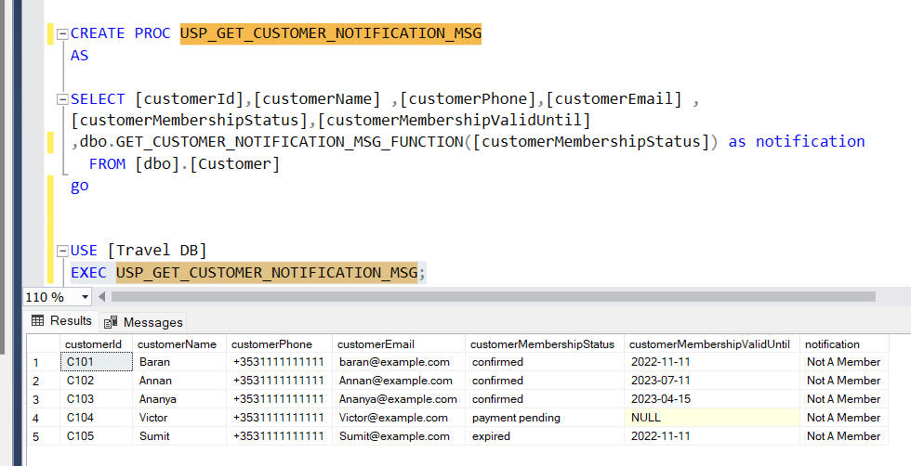

Figure ‑ USP_GET_CUSTOMER_NOTIFICATION_MSG

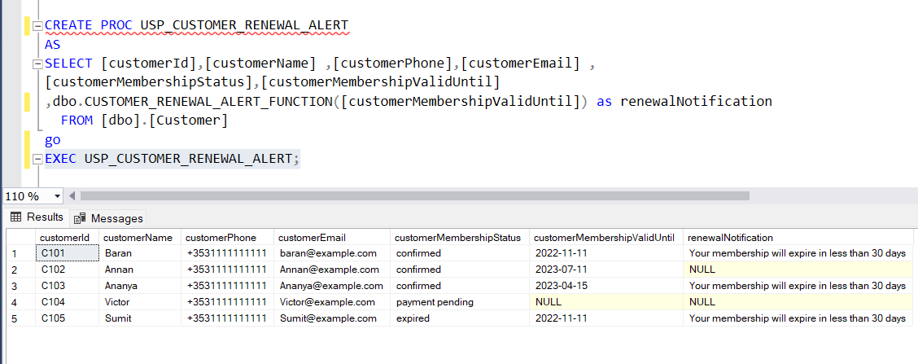

Figure ‑ USP_CUSTOMER_RENEWAL_ALERT

1. Customers should be able to access a list of all their bookings through the application. Customers who have made several bookings or who wish to examine their earlier bookings for reference or record-keeping purposes would appreciate this functionality. The application allows consumers to examine the particular details of the bundle they have selected for each booking. This might include information regarding the package's cost, duration, features, and any other pertinent information.

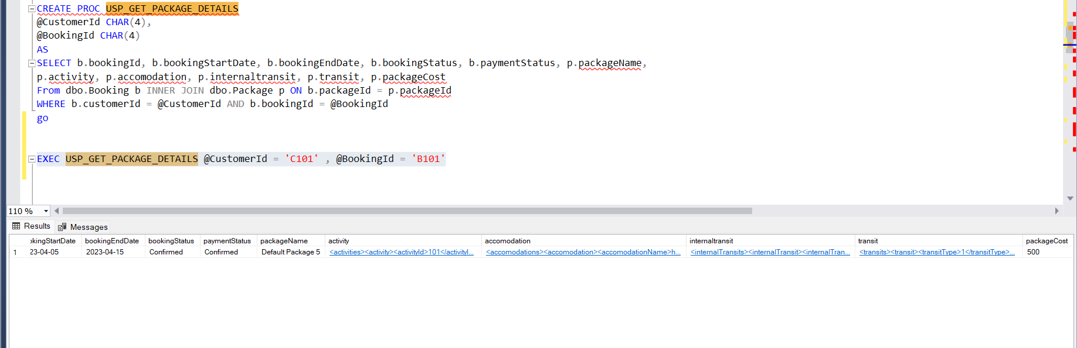

Figure ‑ USP_GET_PACKAGE_DETAILS

1. The programme displays a full list of all available services for the service provider to peruse. Service providers should be able to track the status of their services. They should be able to mention the service in each of the categories that they have posted.

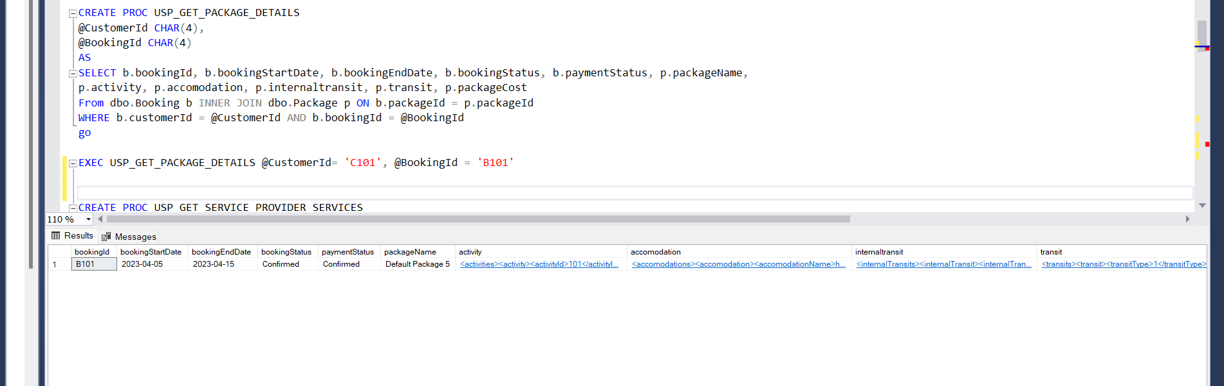

Figure ‑ USP_GET_SERVICE_PROVIDER_SERVICES

1. The application's administrator should be able to manage services and service providers. The application specifically allows the administrator to examine all newly added services as well as verify the validity of service providers and their services by reviewing their information. 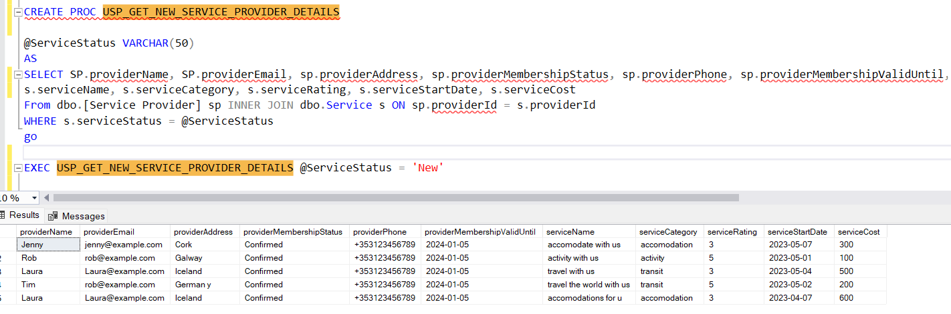

Figure ‑ USP_GET_NEW_SERVICE_PROVIDER_DETAILS

1. The application should reward people who utilise it. The programme allows admins to check the users and the number of reservations they have made, and if the total booking value surpasses 5000 euros, the business will renew its membership for the next year.

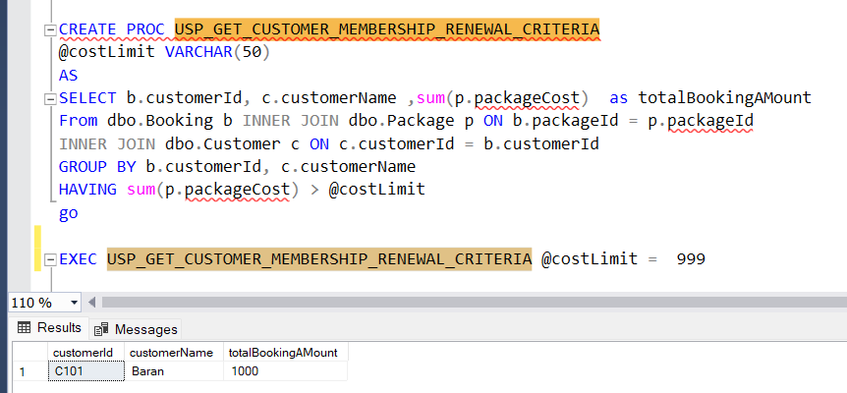

Figure ‑ USP_GET_CUSTOMER_MEMBERSHIP_RENEWAL_CRITERIA

1. Managing service reviews and ensuring that all services are evaluated and updated on a regular basis. The Service Review Log entity may help the business stay organised and efficient by filtering the list of services that have not been evaluated in the last year and should be submitted to re-review, eventually leading to a better customer experience. 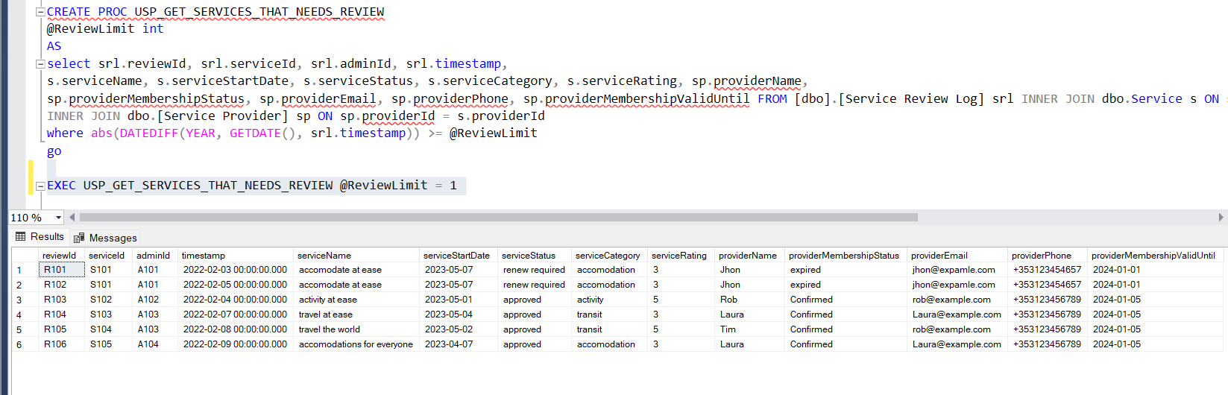

Figure ‑ USP_GET_SERVICES_THAT_NEEDS_REVIEW

1. Packages can be listed out and can be added or modified based on user preferences. Admin can search for any particular service (XML format) from the Packages table and list out the same. Any particular activity or accommodation etc can be modified if the service provider is no longer providing the service for the same.

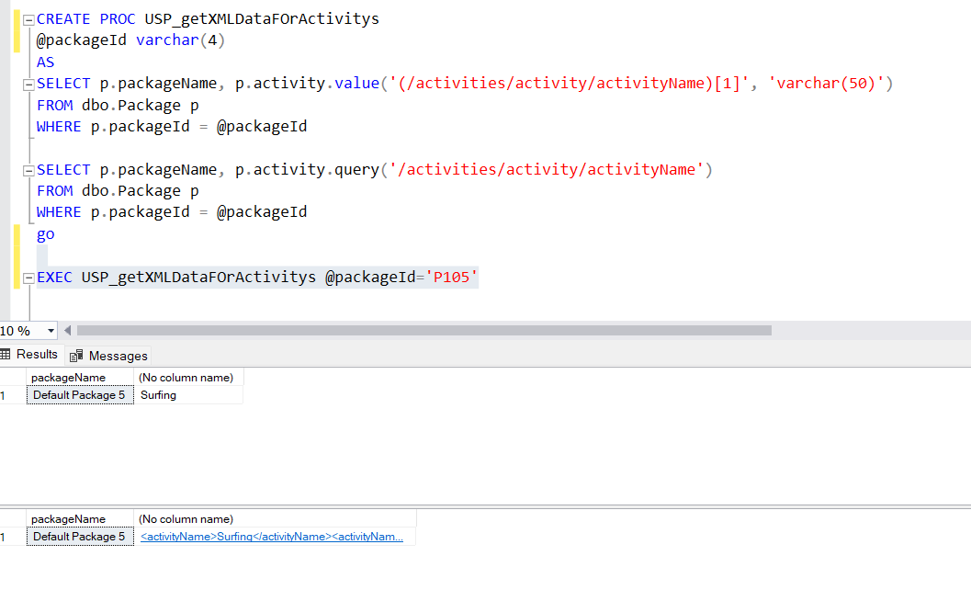

Figure ‑ USP_getXMLDataFOrActivity

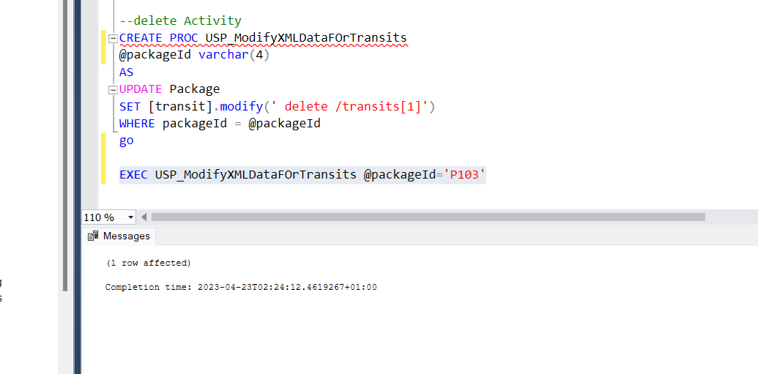

Figure ‑ USP_ModifyXMLDataFOrTransit

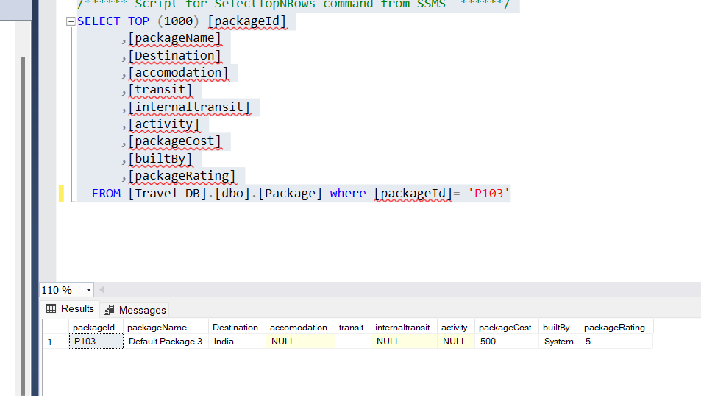

Figure ‑ DATA FRO USP_ModifyXMLDataFOrTransit

# Business Rules

Apart from all the business requirements that the system should fulfil, there are some business rules that the system should follow at all times. Following is the list of rules that should be addressed.

1. A customer is only allowed to register with the system only if he is 18 years of age. We need to have this customer age check constraint on the customer table.

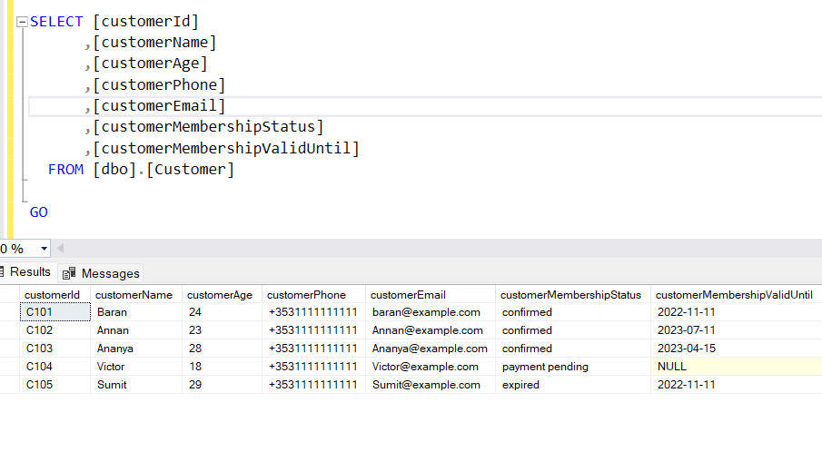

Figure ‑ AGE CONSTRAINT

1. When the customer membership status is expired, all the bookings related to the customer whose booking status is not confirmed are set to ‘renewal required’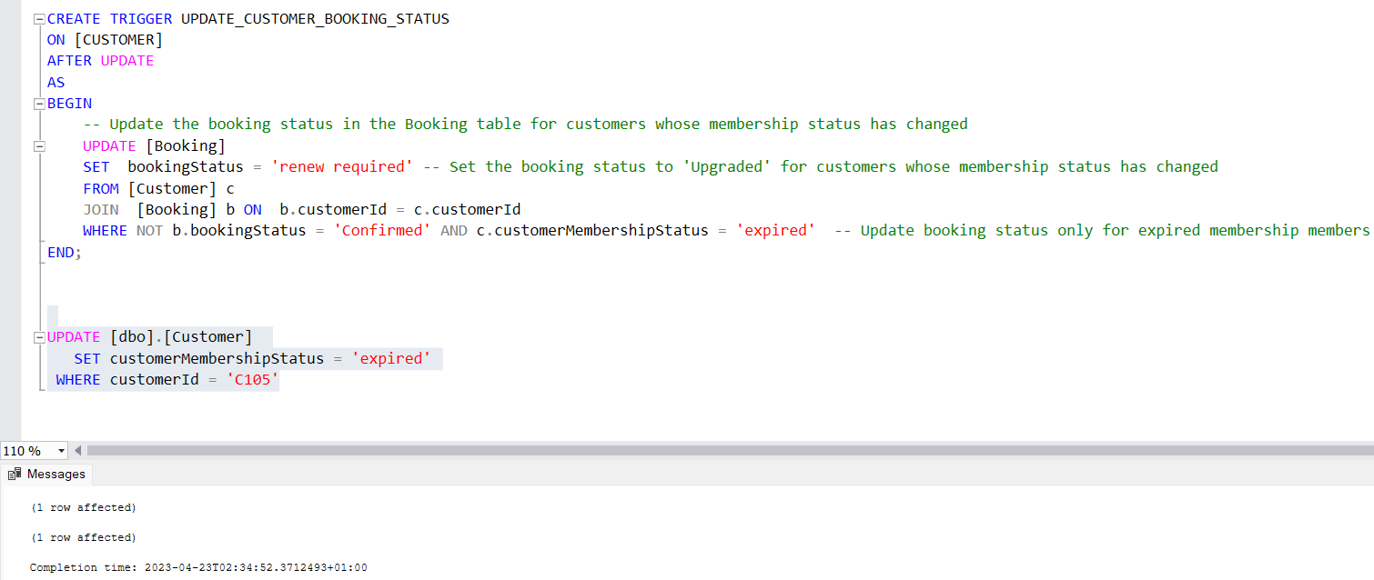

Figure ‑ UPDATE_CUSTOMER_BOOKING_STATUS TRIGGER

1. Only the services that have been approved by the Admin will be displayed to the users. This is to make sure that the user does not accidentally book a service that is not reviewed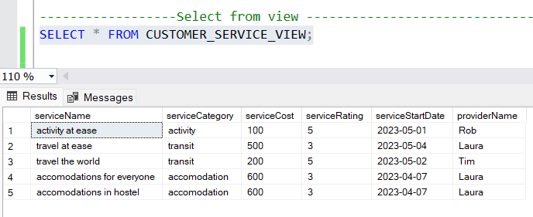

Figure ‑ VIEW FOR CUSTOMERS

1. If the service provider membership is ‘expired’, all the services posted by service provider will have their service status set to ‘renewal required’

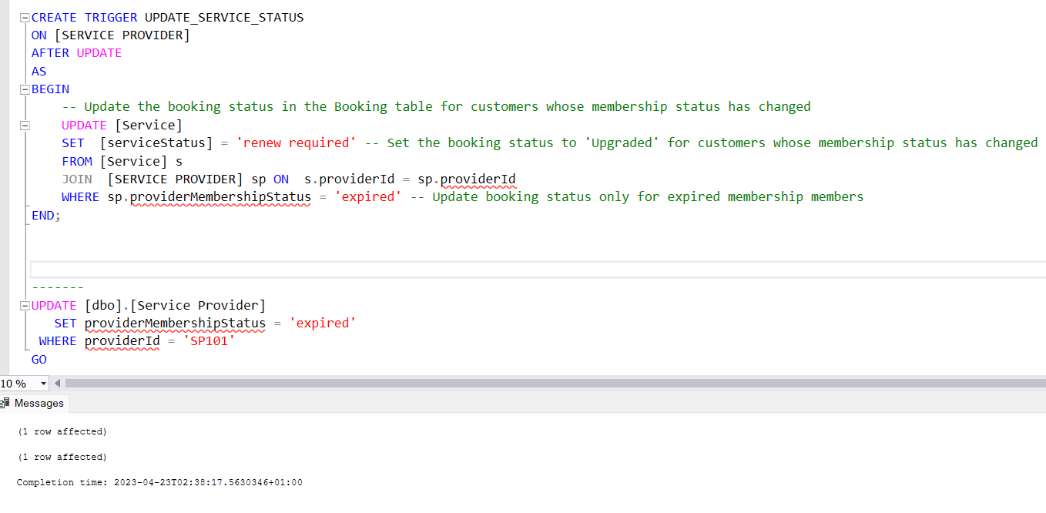

Figure ‑ UPDATE_SERVICE_STATUS TRIGGER

# Entity Relation Diagram

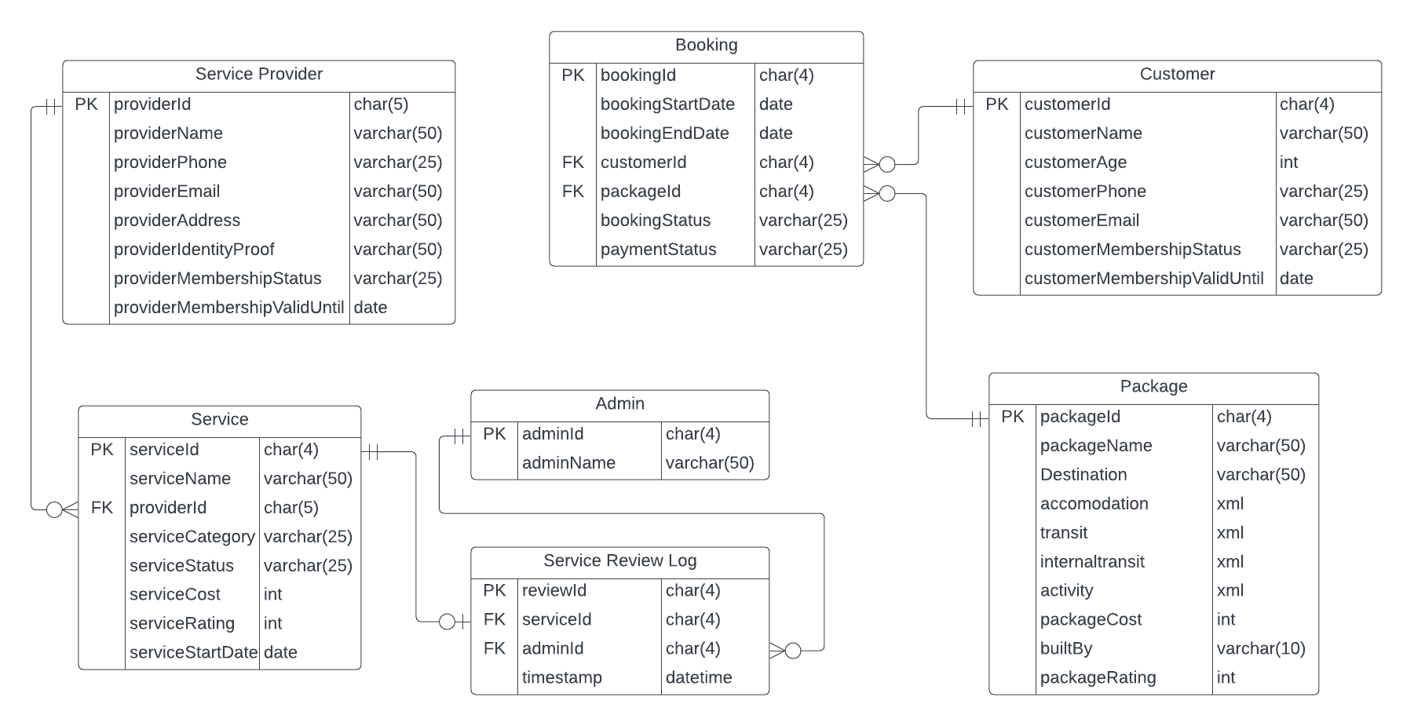

Figure ‑ E-R DIAGRAM

The Entity Relation is modal and collectively shows the logical structure and depicts how different entities are collaborating with each other within the travel system. This Travel website will help connect various actors such are customers, service providers, and admins to collaborate on a number of tasks like building draft packages, booking a package for travel and reviewing service etc. This application has 3 main users: Admin, Service Provider, and Customer. Another major central entity is the Booking Entity.

The first point of focus is the admin, who is required to go through the services and add their review for the services. Since the service and admin are not dependent, a “ServiceReviewLog” association entity is created. The reviews are saved in a “ServiceReviewLog” table along with the timestamp to keep a record of the indirect association between the admin and the services reviewed by him. The timestamp can be later used to find the services that are not recently reviewed and should be sent for re-review. One and only one Admin can review a Service while there is n number of services that can be reviewed by any Admin.

The second focus area is Service Providers and Services. We have a “Service Provider” entity to keep the record of the providers and the associated information. A service provider can offer several services or can offer no services if they haven’t put up any service yet. Therefore, we have created a separate entity “Service” that keeps a record of the category of service its status, the tariff for the service as well as the rating. This Service entity is linked to the service provider.

The third focus is our customers on the website who should register with us with a name, valid phone number email. The data for the customer is stored in the “Customer” Entity. A Customer can create a draft package and since the plan is to convert the draft package to an actual package available for other customers, for this reason, we have created a “Draft Package” entity which is linked to the customer

The next central entity is the “Booking” entity. This entity stores information about booking, booking, travel dates, booking and payment status. The Booking entity is associated with Customer and Package entity. The Customer entity can have zero or more bookings. The booking entity is having package Id as it has to store the information about the Package chosen by the customer for booking. A booking can have only one package associated with it. There can be one or more bookings associated with the same “Package” entity as more than one customer can select the same package for booking.

A ”Package” entity is the collection of all the services with a total cost, rating and builtBy attributes that a customer can use for booking. The ‘builtBy’ attribute can have a value like a system id or a customer id, as the package can be created by the customer as well. This entity is associated with the Booking Entity so as to have knowledge about the services that are chosen for booking.

## XML

Package Entity fields like accommodation, transit, internal transits and activity are having the data type as XML. The reason for selecting XML as the data format is due to the possibility of various packages having different relationships with these fields. In other words, certain packages may have more or fewer instances of these fields or include different sorts of information. Unstructured data may be efficiently kept within the package table and all the metadata linked to these fields by utilizing XML as the data type. That is, independent of the exact linkages between the package and these fields, all essential information may be gathered and saved in an organized and readily retrievable manner. This gives us a hybrid database that is no longer bound to the fixed relational schema for the fields having type XML. This will provide flexibility to the user as well as to the system to accommodate user preferences along with maintaining a relational database structure. Overall, using XML as the data type for these package fields is a strategic decision that allows for the efficient and flexible storing of data linked to various package kinds and configurations.

## Referential Integrity

Every entity in this system is associated with a Primary key that will uniquely identify the records in the tables. These primary keys are then referenced as foreign keys in the other entities. The Service Provider’s providerId is referenced in the Services entity as the service can exist only when it is associated with a service provider.

The service review log entity has two foreign key references, one with the adminId in the Admin table and the other one with the serviceId in the service table. These

two association is chosen as the service review log table keeps a record of the review that an admin has done for a particular service.

The booking entity keeps records of the bookings that are made by the customer. This entity is also associated with two foreign keys, one with the customer as the booking has to be associated with a customer there is no existence of booking if there is no customer, and the other is with the package entity as the customer will choose a package that he wishes to book and there can be no booking made if no package is selected by the customer.

We have not implemented any cascade restriction feature in any of the tables because of the fact that the business wishes to maintain the records even after any Primary Key record has been deleted so as to keep a reference for future use.

# Data Flow Diagram

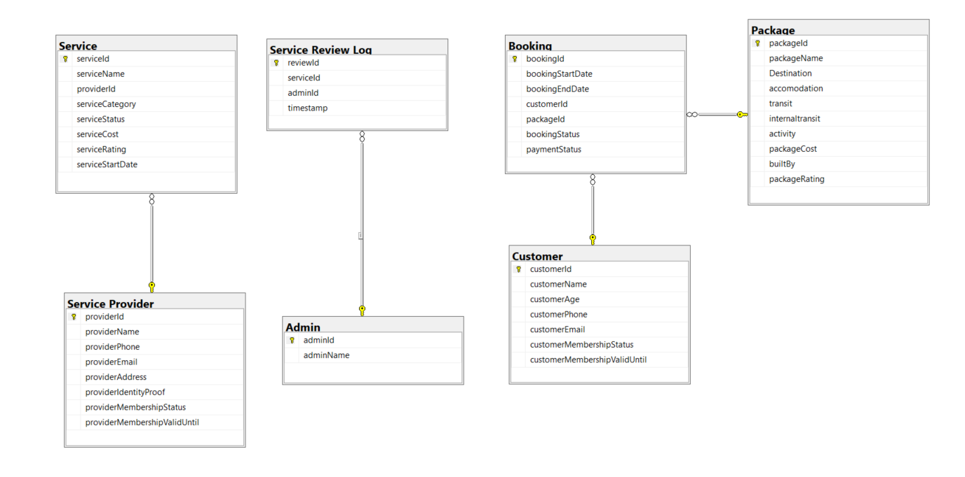

Figure ‑ DATA FLOW DIAGRAM

# Views

Views can represent the subset of data along with limiting the exposer of data from the system. It can also be used to build a simple-looking dataset while hiding the underneath complex structure. In our system, we wanted to use the principles of Views.

The first case is a view of the customer. We want our customers to view the service that is not only approved but also the membership status of the service provider confirmed. This is to ensure that the user can only check and select the services from the verified service provider

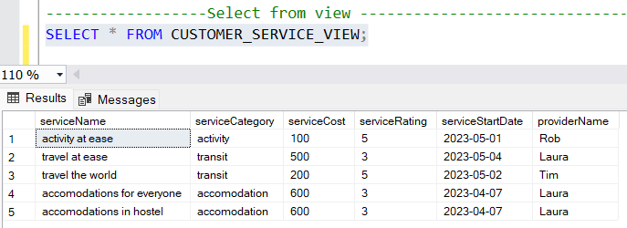

Figure ‑ CUSTOMER_SERVICE_VIEW

The second scenario is a view for the Admin. We want the admin to view the booking of the customer whose customer membership status is confirmed so as to build up special offers to the customers based on the bookings they have made.

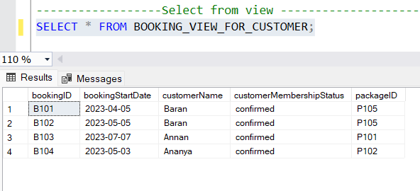

Figure ‑ BOOKING_VIEW_FOR_CUSTOMER

# Innovation

The business here is to create a one-stop destination for both the service provider and the customers. We want this business to fulfil the needs of both the service providers and the customers. The service providers can post their services directly to the application and once the admin approves the status of the service provider and the services they have posted, these services are posted to the application and are made available for the customers to choose from. Customers can select from the prebuild packages and with the use of a hybrid database design, they can modify or delete any service that they do not wish to book. This will give customers the freedom to build their own custom packages and therefore provides the best user experience. Building custom packages is one of the major features that this business is offering.

# Conclusion

The report outlines and addresses the notion of creating an application that would make trip planning and booking easier. The travel business is quickly developing, and customers are increasingly seeking personalized travel experiences. Travel planning and booking, on the other hand, may be time-consuming and perplexing. The objective is to build a platform that serves both customers/travellers and service providers. The emphasis is on providing consumers with a hassle-free and cost-effective experience. Customers will be able to choose from a variety of destinations, hotels, and means of transportation using the application. By implementing the application, service providers will be able to promote their availability and immediate benefit. The company's earnings will be generated by the membership fee paid by travellers and service suppliers.

Developing this sort of application required a lot of modules that are interdependent on each other. We have split up our application into a modular architecture where the main focus is to create an interface for the customers and service providers. This system is designed to provide an effective solution to all types of users of this application. We wanted to build a database system that is efficient and consistent.

In summary, the proposed application seeks to provide customers with a simple and cost-effective trip planning and booking experience. By developing a one-stop location for both passengers and service providers, the company intends to streamline the vacation planning process and increase the business prospects of service providers.

# Bibliography

Hoffer, Jeffrey *et al.* (2019) *Modern Database Management, Global Edition*. Harlow, UNITED KINGDOM: Pearson Education, Limited. Available at: <http://ebookcentral.proquest.com/lib/dbsie/detail.action?docID=5785537> (Accessed: 3 March 2023).

‘View (SQL)’ (2023) *Wikipedia*. Available at: <https://en.wikipedia.org/w/index.php?title=View_(SQL)&oldid=1146274287> (Accessed: 22 April 2023).

*What is a Data Flow Diagram* (no date) *Lucidchart*. Available at: <https://www.lucidchart.com/pages/data-flow-diagram> (Accessed: 3 March 2023).